**PRACTICAL - 1**

**AIM: Demonstrate the connection between two LAN connections with one router using cisco packet tracer**

**THEORY:**

**ROUTER**

* **The router is a physical or virtual internetworking device that is designed to receive, analyse, and forward data packets between computer networks.**
* **It shares information with other routers in networking.**
* **It uses the routing protocol to transfer the data across a network.**
* **It performs the traffic directing functions on Internet.**
* **The main purpose of a router is to connect multiple networks and forward packets to its destination either for its own networks or other networks.**
* **Router operates at the network layer**

**LAN**

* **LAN networking comprises cables, switches, routers and other components that let users connect to internal servers, websites and other LANs via wide area networks.**
* **Typically, a LAN encompasses computers and peripherals connected to a server within a distinct geographic area such as an office or a commercial establishment.**
* **Computers and other mobile devices use a LAN connection to share resources such as a printer or network storage.**
* **Ethernet and Wi-Fi are the two primary ways to enable LAN connections**
* **A local area network (LAN) is a group of computers and associated devices that share a common communications line or wireless link to a server.**

**TOPOLOGY:**

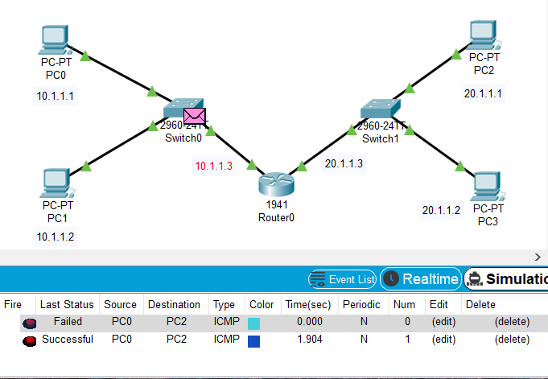

**STEPS OF CONFIGURATION**

**First, we need to create the topology. So, click on the devices and drop on workplace and connect all the devices with the necessary cables**

1. **Configure the router using CLI**
2. **Click on router and then go to the CLI tab**
3. **To get in to the configuration mode, write router > enable**
4. **To configure the terminal, write router # configure terminal**
5. **To get into privilege mode, write router(config) #interface gigabitEthernet0/0**
6. **To set the IP address, write router(config-if) #ip address 10.1.1.3 255.255.0.0**
7. **To switch on the router, write router(config-if) #no shut**

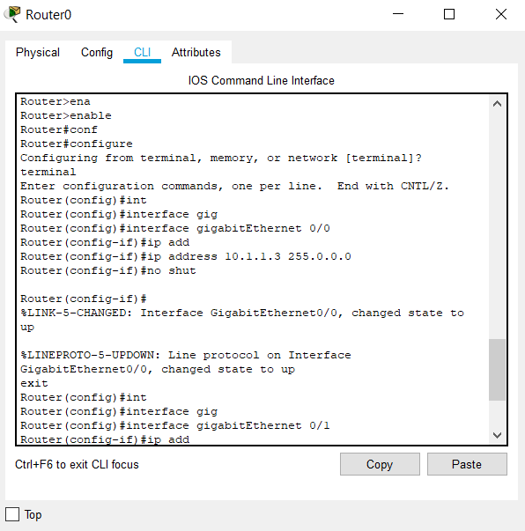

**Follow the same to provide IP address 20.1.1.3 255.0.0.0 to interface 0/1**

**Provide IP address to all the PC connected in LAN**

1. **Click on PC, go to Desktop tab in that IP Configuration option**
2. **Provide IP address and default gateway.**
3. **Default IP Address and Gateway of all PC is 0.0.0.0**
4. **Provide IP Address to All for PC as 10.1.1.1, 10.1.1.2, 20.1.1.1, 20.1.1.2**
5. **Also give Gateway to all PC of 1st LAN as 10.1.1.3**
6. **Give Gateway to all PC of 2nd LAN as 20.1.1.3**

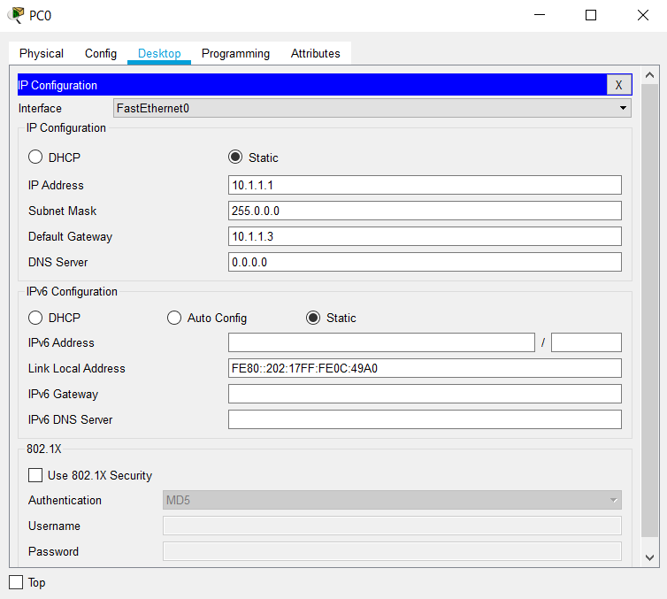

**CHECK NETWORK TOPOLOGY**

* **To check the connections are working properly or not drop one package on the one PC of network 1 and receive it from the PC of network 2**



* **Checking Network Topology using PING command**

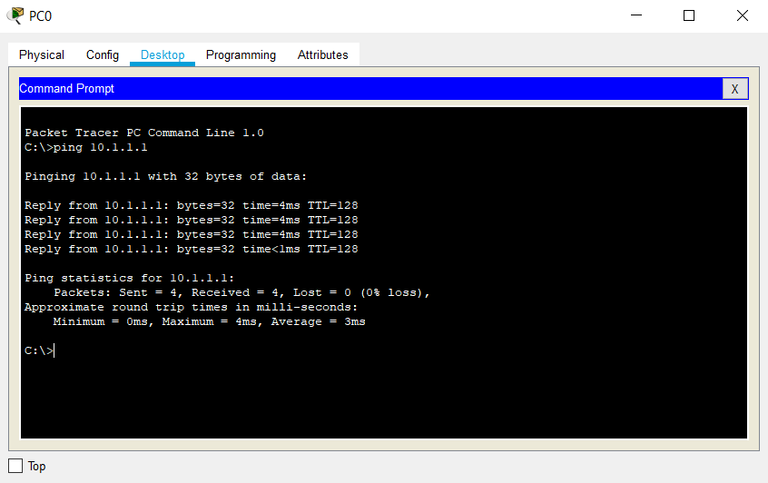

**CONCLUSION:**

From this practical, I learnt about Static and Dynamic assigning of IP Address. Also, I was able to understand the modes of router and how to configure the router with the help of CLI. We also learn the use of gateway while working with two different networks.